Chapter 3, Problem 27.

Use nodal analysis to determine voltages v₁, v₂, and v₃ in the circuit in Fig. 3.76.

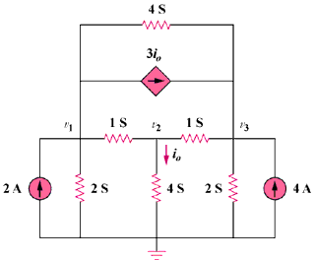

Figure 3.76
For Prob. 3.27.

